Working with DotSpatial controls
  - Tutorial (1)
Purpose of this tutorial: Become familiar with the DotSpatial map control and its following functionalities: ZoomIn, ZoomOut, Zoom to Extent, Select, Measure, Pan, Info, and load data.
This tutorial has 5 important steps.
Step 1: Download the DotSpatial class library
Step 2: Add the DotSpatial reference and change the compile option.
Step 3: Add the DotSpatial Controls into the Visual Studio Toolbox.
Step 4: Design the GUI. (GUI - Graphical User Interface)
Step 5: Write the code for implementing the map operations.
Step 1: Download the DotSpatial class library
1. Download the DotSpatial class library (x86 Framework 4.0.zip) from the following URL.
http://dotspatial.codeplex.com
2. Unblock and unzip the downloaded folder. Right click on the downloaded folder and choose the properties from the context menu. On the folder properties window click unblock button. After unblock the folder and unzip it.
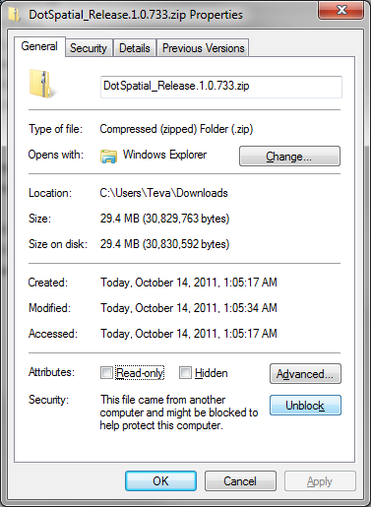
Fig.1. Properties window of the downloaded folder
Step 2: Add the DotSpatial reference and change the compile option.
2.1) Add the DotSpatial references
1. Right click over the project on the solution explorer and select the add reference from the context menu.
2. Add the following 4 references from the downloaded folder. fig.5
DotSpatial.Controls.dll, DotSpatial.Data.dll, DotSpatial.Data.Forms.dll, DotSpatial.Symbology.dll
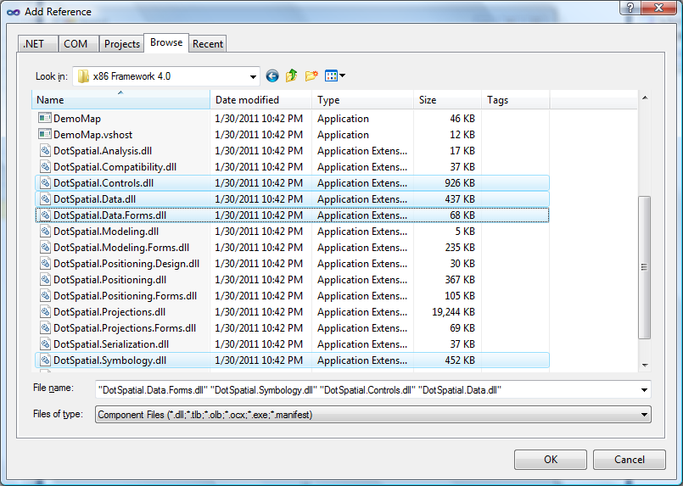
Fig.2. required references
2.2) Change the target framework from .Net Framework 4 Client Profile to .Net Framework 4
1) Right click over the project on the solution explorer and select the properties from the context menu.
2) Change the target framework from .Net Framework 4 Client Profile to .Net Framework 4.
In C#.net application: Choose the application tag from the properties window. Choose the .Net Framework 4 from the target framework dropdown list.
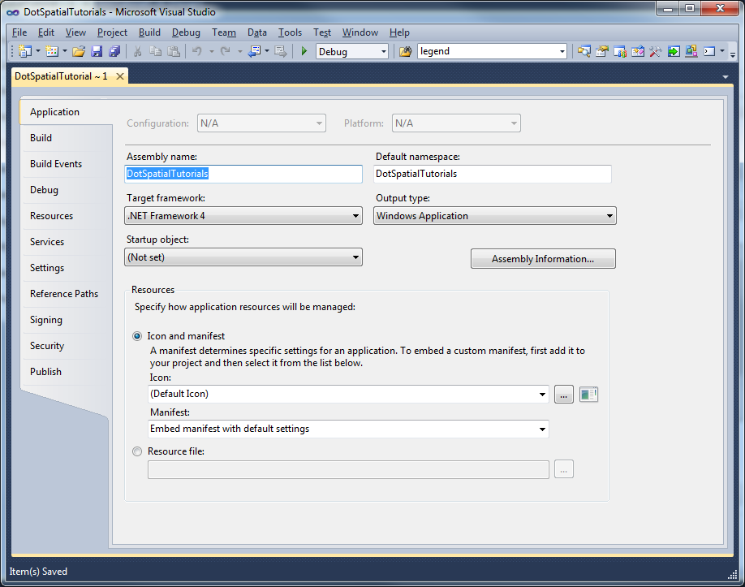
Fig.3 Change the Target framework in C#.net.
In VB.net application: Choose the compile tag from the properties window. Select the Advanced Compile Options button.
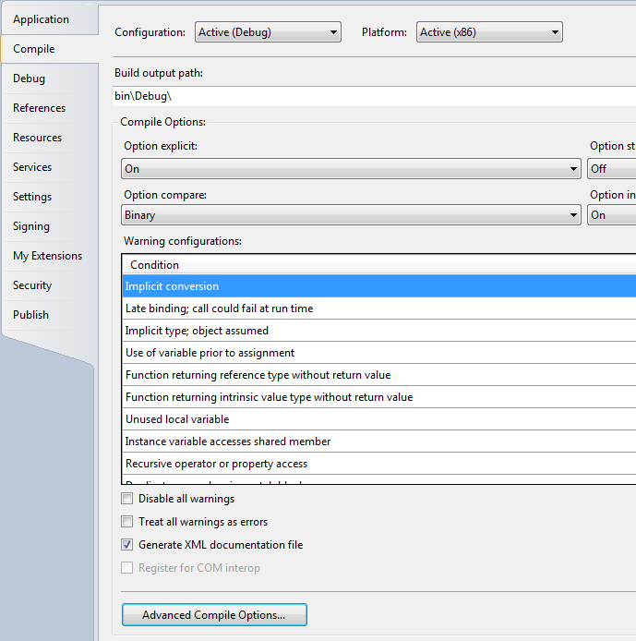
Fig.4 Choose the Advanced Compile Options on the Compile tag.
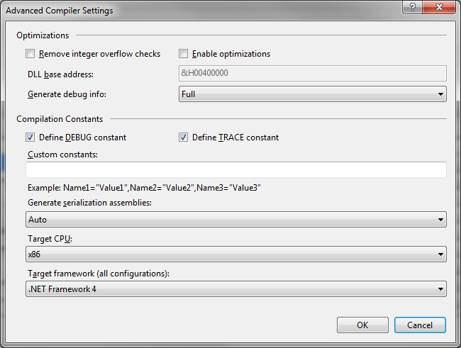
Fig.5 Select the .Net Framework 4 from the Advanced Compile Settings Window.

Step 3: Add the DotSpatial Controls into the Visual Studio Toolbox.
3.1) Creating a new Tab on the ToolBox window and adding the DotSpatial class library
Create a new project in C# and select the ToolBox on the standard menu bar. Right click on the ToolBox window and choose "Add Tab" from the context menu. Fig.3 Enter the new tab name as DotSpatial. On the DotSpatial tab right click and select the choose items from the context menu.
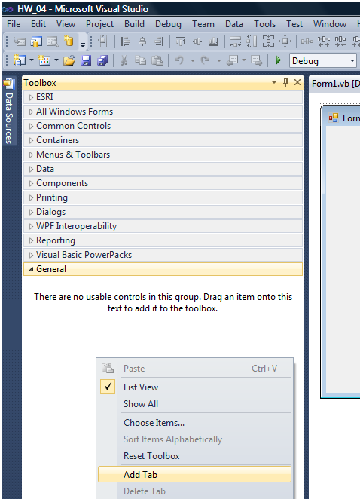
Fig.6. Adding a new tab
Click the Browse button on the Choose Tool Box Items window. Fig.4
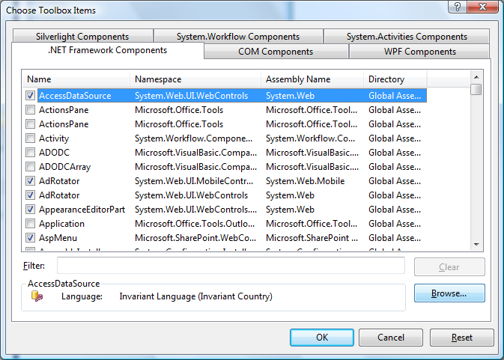
Fig.7. Choose Toolbox Items window
Select the DotSpatial.Controls.dll from the downloaded folder. (fig.5)
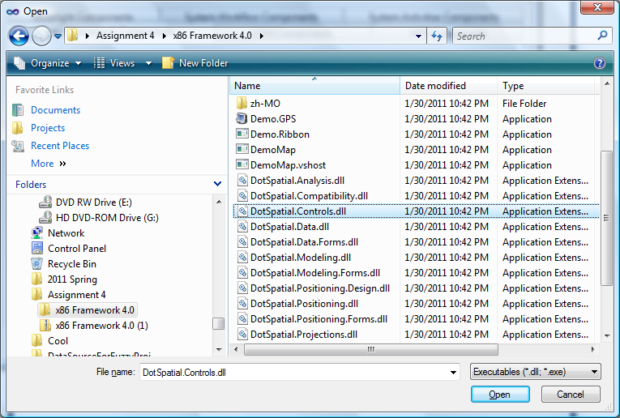
Fig.8 Downloaded DotSpatial folder
Make sure the AppManager is checked on the Choose Toolbox Items window. fig.6
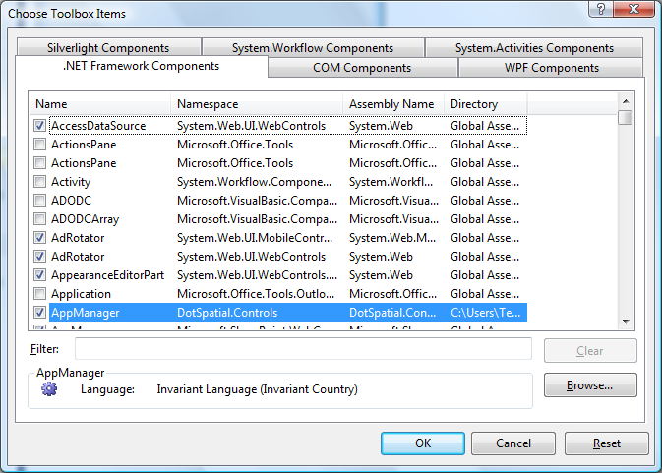
Fig.9. AppManager should be checked on the Choose Toolbox Items.

Step 4: Design the GUI. (Graphical User Interface)
Design the GUI as follows:
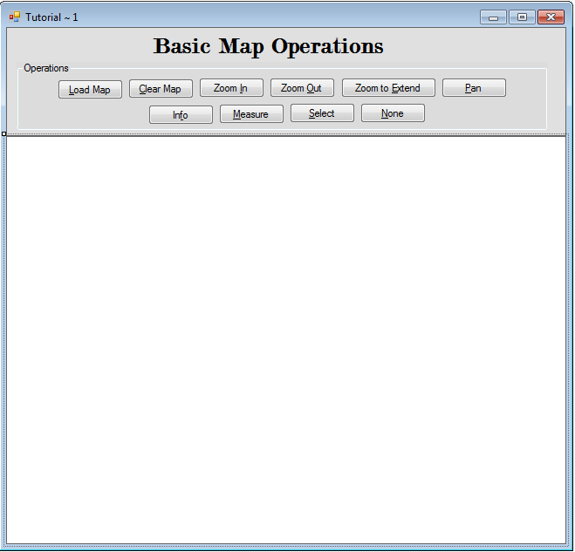
Map Control
fig.10. Final GUI
Interface design considerations.
1. Add 2 panel controls on the form.
1.1) Name the first panel as pnlOperations and set the dock property as Top.
1.2) Name the second panel as pnlMap and set the dock property as Fill.
2. Drag the map control on to the pnlMap from the tool box, under the DotSpatial tab. Set the dock property of map to Fill.
3. Add a group box on to the pnlOperations and name it as grbOperations.
4. Create ten buttons inside the group box.
4.1) Set the buttons properties as follows:
Control | Name | Text
Button1 | btnLoad | &Load Map
Button2 | btnClear | &Clear Map
Button3 | btnZoomIn | Zoom &In
Button4 | btnZoomOut | Zoom &Out
Button5 | btnZoomToExtend | Zoom to &Extent
Button6 | btnPan | &Pan
Button7 | btnInfo | In&fo
Button8 | btnMeasure | &Measure
Button9 | btnSelect | &Select
Button10 | btnNone | &None

4.2) Use shortcut keys for the button click event. Ex: Load Map button's short cut key is Shift + L. To implement this feature, on the properties window of the button select the Text property and use the & sign in front of any letter. In the load button case, Text property should be &Load Map
5. Add a title label above the group box. Name of the label should be lblTitle and the text property of the label is Basic Map Operations.
Step 5: Write the code for implementing the map operations.
- Add the following namespace
C#.net

//Required namespace
using DotSpatial.Controls;

VB.net
'Required namespace
Imports DotSpatial.Controls

- Double click over the button on the form to get the selected button's click event code view.
C#.net

private void btnLoad_Click(object sender, EventArgs e)
{
//AddLayer method is used to add shape layers
map1.AddLayer();
}

private void btnClear_Click(object sender, EventArgs e)
{
//ClearLayers method is used to remove all the layers from the mapcontrol
map1.ClearLayers();
}

private void btnZoomIn_Click(object sender, EventArgs e)
{
//ZoomIn method is used to ZoomIn the shape file
map1.ZoomIn();
}

private void btnZoomOut_Click(object sender, EventArgs e)
{
//ZoomOut method is used to ZoomIn the shape file
map1.ZoomOut();
}

private void btnZoomToExtent_Click(object sender, EventArgs e)
{
//ZoomToMaxExtent method is used to Extent the shape file
map1.ZoomToMaxExtent();
}

private void btnPan_Click(object sender, EventArgs e)
{
//Pan function is used to pan the map
map1.FunctionMode = FunctionMode.Pan;
}

private void btnInfo_Click(object sender, EventArgs e)
{
//Info function is used to get the information of the selected shape
map1.FunctionMode = FunctionMode.Info;
}

private void btnMeasure_Click(object sender, EventArgs e)
{
//Measure function is used to measure the distance and area
map1.FunctionMode = FunctionMode.Measure;
}

private void btnSelect_Click(object sender, EventArgs e)
{
//Select function is used to select a shape on the shape file
map1.FunctionMode = FunctionMode.Select;
}

private void btnNone_Click(object sender, EventArgs e)
{
//None function is used to change the mouse cursor to default
map1.FunctionMode = FunctionMode.None;
}

VB.net

Private Sub btnLoad_Click(ByVal sender As System.Object, ByVal e As System.EventArgs) Handles btnLoad.Click
'AddLayer() method is used to add a shapefile in to mapcontrol
Map1.AddLayer()
End Sub

Private Sub btnRemove_Click(ByVal sender As System.Object, ByVal e As System.EventArgs) Handles btnClear.Click
'Clear() method is used to clear the shapelayers from mapcontrol
Map1.Layers.Clear()
End Sub

Private Sub btnZoomIn_Click(ByVal sender As System.Object, ByVal e As System.EventArgs) Handles btnZoomIn.Click
'ZoomIn method is used to ZoomIn the shape file
Map1.ZoomIn()
End Sub

Private Sub btnZoomOut_Click(ByVal sender As System.Object, ByVal e As System.EventArgs) Handles btnZoomOut.Click
'ZoomOut method is used to ZoomIn the shape file
Map1.ZoomOut()
End Sub

Private Sub btnZoomToExtend_Click(ByVal sender As System.Object, ByVal e As System.EventArgs) Handles btnZoomToExtend.Click
'ZoomToMaxExtent method is used to Extent the shape file
Map1.ZoomToMaxExtent()
End Sub

Private Sub btnMeasure_Click(ByVal sender As System.Object, ByVal e As System.EventArgs)
'Measure function is used to measure the distance and area
Map1.FunctionMode = DotSpatial.Controls.FunctionMode.Measure
End Sub

Private Sub btnInfo_Click(ByVal sender As System.Object, ByVal e As System.EventArgs) Handles btnInfo.Click
'Info function is used to get the information of the selected shape
Map1.FunctionMode = FunctionMode.Info
End Sub

Private Sub btnMeasure_Click_1(ByVal sender As System.Object, ByVal e As System.EventArgs) Handles btnMeasure.Click
'Measure function is used to measure the distance and area
Map1.FunctionMode = FunctionMode.Measure
End Sub

Private Sub btnSelect_Click(ByVal sender As System.Object, ByVal e As System.EventArgs) Handles btnSelect.Click
'Select function is used to select a shape on the shape file
Map1.FunctionMode = FunctionMode.Select
End Sub

Private Sub btnNone_Click(ByVal sender As System.Object, ByVal e As System.EventArgs) Handles btnNone.Click
'None function is used to change the mouse cursor to default
Map1.FunctionMode = FunctionMode.None
End Sub

Private Sub btnPan_Click(ByVal sender As System.Object, ByVal e As System.EventArgs) Handles btnPan.Click
'Pan function is used to pan the map
Map1.FunctionMode = FunctionMode.Pan
End Sub

3. To display the tool tip message for the buttons, add the following code in the form load event.
Double click over the form for getting the form load event code view.

C#.net

private void frmTutorial1_Load(object sender, EventArgs e)
{
ToolTip btnToolTip = new ToolTip();
btnToolTip.SetToolTip(btnLoad, "Shift + L");
btnToolTip.SetToolTip(btnZoomIn, "Shift + I");
btnToolTip.SetToolTip(btnZoomOut, "Shift + O");
btnToolTip.SetToolTip(btnClear, "Shift + C");
btnToolTip.SetToolTip(btnZoomToExtent, "Shift + E");
btnToolTip.SetToolTip(btnLoad, "Shift + L");
btnToolTip.SetToolTip(btnInfo, "Shift + f");
btnToolTip.SetToolTip(btnMeasure, "Shift + M");
btnToolTip.SetToolTip(btnSelect, "Shift + S");
btnToolTip.SetToolTip(btnNone, "Shift + N");
btnToolTip.SetToolTip(btnPan, "Shift + P");
}

VB.net

Private Sub Form1_Load(ByVal sender As System.Object, ByVal e As System.EventArgs) Handles MyBase.Load
Dim btnToolTip As New ToolTip()
btnToolTip.SetToolTip(btnLoad, "Shift + L")
btnToolTip.SetToolTip(btnZoomIn, "Shift + I")
btnToolTip.SetToolTip(btnZoomOut, "Shift + O")
btnToolTip.SetToolTip(btnClear, "Shift + C")
btnToolTip.SetToolTip(btnZoomToExtend, "Shift + E")
btnToolTip.SetToolTip(btnPan, "Shift + P")
btnToolTip.SetToolTip(btnInfo, "Shift + F")
btnToolTip.SetToolTip(btnMeasure, "Shift + M")
btnToolTip.SetToolTip(btnSelect, "Shift + S")
btnToolTip.SetToolTip(btnNone, "Shift + N")
End Sub

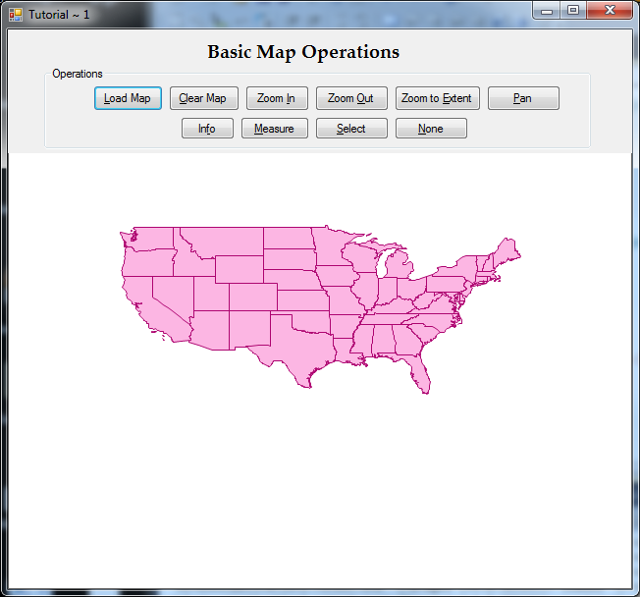
fig.10. Project Output for state shape file.

