Raster Data Operations in DotSpatial
  - Tutorial (2)
Purpose of this tutorial: Become familiar with the following raster operations in DotSpatial:
1. Loading different formats of raster data in DotSpatial.
2. Implementing the hill shade.
3. Change the color of the raster data.
4. Multiply the raster data.
5. Reclassify the raster data.
6. Get the mouse clicked point values on the raster data layer.
This tutorial has 5 important steps.
Step 1: Download the DotSpatial class library
Step 2: Add the DotSpatial reference and change the compile option.
Step 3: Add the DotSpatial Controls into the Visual Studio Toolbox.
Step 4: Copy the Data Extensions folder to the debugs folder of the current project
Step 5: Design the GUI. (GUI - Graphical User Interface)
Step 6: Write the code for implementing the map operations.
Step 1: Download the DotSpatial class library
This step is the same as Tutorial #1 step 1.
Step 2: Add the DotSpatial reference and change the compile option.
1.1) Adding the references.
DotSpatial.Data.Forms.dll, DotSpatial.Symbology.dll, DotSpatial.Controls.dll, DotSpatial.Projections.dll, DotSpatial.Data.dll, DotSpatial.Topology.dll
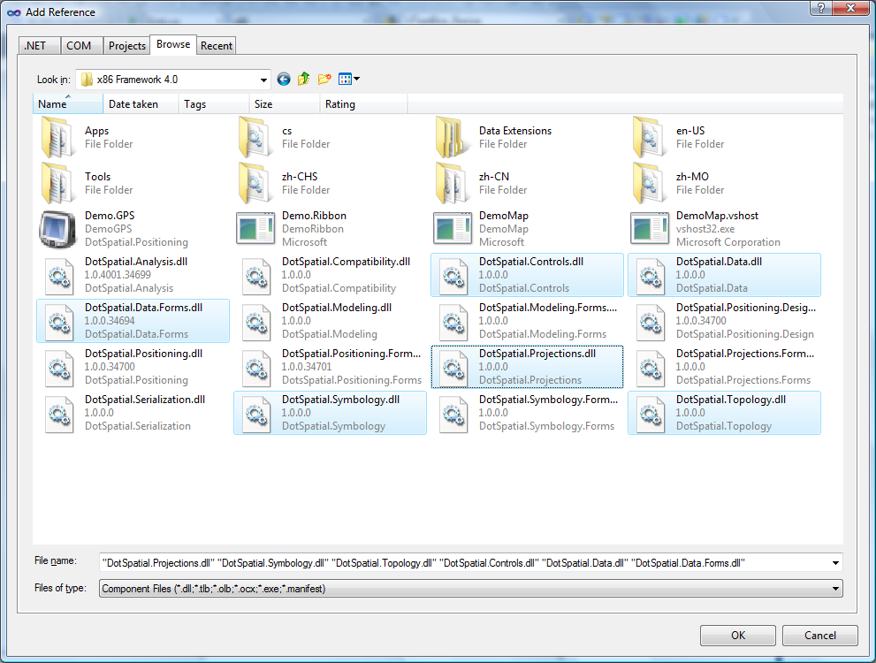
Fig. 1 Required references.
2.2) Change the compile option.
Change the compile option from .Net Framework 4 Client Profile to .Net Framework4.
This step is the same as the Tutorial # 1 step 2.2.
Step 3: Add the DotSpatial Controls into the Visual Studio Toolbox.
This step is the same as the Tutorial # 1 step 3.
Step 4: Copy the Data Extension folder from your downloaded folder to your current project bin/debug folder. The .dlls from this folder is necessary for GDAL data provider access.
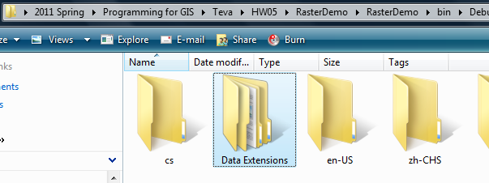
Fig. 2 Data Extensions folder from DotSpatial downloaded unzip folder

Step 5: Design the GUI
Design the GUI as follows:
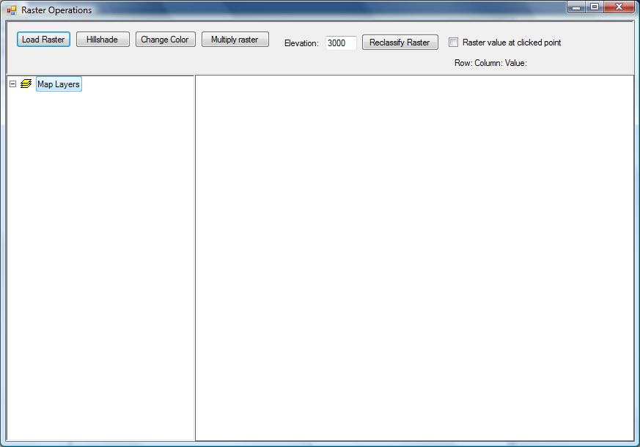
Fig. 3 Final GUI
Interface design considerations.
1. Add three panel controls. Panel control's properties should be as follows:
Properties | Panel1 | Panel2 | Panel3
Name | pnlOperations | pnlLegend | pnlMap
Dock | Top | Left | Fill

2. Add five buttons. Button properties should be as follows:
Properties | Button1 | Button2 | Button3 | Button4 | Button5
Name | btnLoadRaster | btnHillshade | btnChangeColor | btnMultiplyRaster | btnReclassify
Text | &Load Raster | &Hillshade | Change &Color | &Multiply Raster | &Reclassify Raster

3. Add two label controls. Labels' properties should be as follows:
Properties | Label1 | Label2
Name | lblElevation | lblRasterValue
Text | Elevation | Row: Column: Value:

4. Add a checkbox and it should have the following properties.
Name: chbRasterValue Text : Raster value at clicked point
5. Add a textbox and it should have the following features.
Name: txtElevation Text: 3000
6. Drag a “Legend” control from the DotSpatial tab under toolbox and drop it on pnlLegend. Legend properties should be as follows:
Name: Legend1 Dock: Fill
7. Drag a “Map” control from the DotSpatial tab under toolbox and drop it on pnlMap. Map properties should be as follows:
Name: Map1 Dock: Fill Legend: Legend1
8. Drag an "AppManager" control from DotSpatial tab under toolbox and drop it on the form.
Note: This control is necessary for loading different formats of raster data.
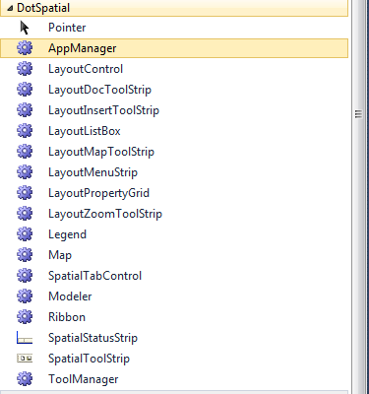
Fig. 4 AppManager
9. Set the properties of AppManager1 as follows:
Map: Map1 Legend: Legend1
Step: 6 Loading the different formats of raster data.
6.1) Import the following namespaces in the coding window.
//Required namespaces
using DotSpatial.Symbology;
using DotSpatial.Controls;
using DotSpatial.Data;
using DotSpatial.Topology;

6.2 ) btnLoadRaster click event should be as follows:

private void btnLoadRaster_Click(object sender, EventArgs e)
{
//AddRasterLayer() method is used to load the raster layers on the map
map1.AddRasterLayer();
map1.ZoomToMaxExtent();
}

Implementing the hill shade.
btnHillshade_Click event should have the following code.
private void btnHillshade_Click(object sender, EventArgs e)
{
if (map1.Layers.Count > 0)
{

//IMapRasterLayer layer = (IMapRasterLayer)map1.Layers[0];

IMapRasterLayer layer =map1.Layers[0] as IMapRasterLayer;

if (layer == null)
{
MessageBox.Show("Please select a raster layer");
return;
}

layer.Symbolizer.ShadedRelief.ElevationFactor = 1;

layer.Symbolizer.ShadedRelief.IsUsed = true;

layer.WriteBitmap();

}
else
{
MessageBox.Show("Please add a layer to the map.");
}
}

Change the color.
btnChangeColor click event should has the following event.
private void btnChangeColor_Click(object sender, EventArgs e)
{
if (map1.Layers.Count > 0)
{
//change the color of raster

//typecast the first layer to MapRasterLayer
IMapRasterLayer layer = map1.Layers[0] as IMapRasterLayer;

if (layer == null)
{
MessageBox.Show("Please add a raster layer.");
return;
}

//set the color scheme

//create an instance for a colorscheme
ColorScheme scheme = new ColorScheme();

//create a new category
ColorCategory category1 = new ColorCategory(2500, 3000, Color.Red, Color.Yellow);

category1.LegendText = "Elevation 2500 - 3000";

//add the category to the color scheme
scheme.AddCategory(category1);

//create another category
ColorCategory category2 = new ColorCategory(1000, 2500, Color.Blue, Color.Green);

category2.LegendText = "Elevation 1000 - 2500";

scheme.AddCategory(category2);

//assign new color scheme
layer.Symbolizer.Scheme = scheme;

//refresh the layer display in the map
layer.WriteBitmap();

}
else
{
MessageBox.Show("Please add a layer to the map.");
}

}

Multiply the raster.
btnMultiplyRaster should has the following event.
private void btnMultiplyRaster_Click(object sender, EventArgs e)
{
if (map1.Layers.Count > 0)
{
IMapRasterLayer layer = map1.Layers[0] as IMapRasterLayer ;

if (layer == null)
{
MessageBox.Show("Please select a raster layer");
}

IRaster demRaster = layer.DataSet;

string[] rasterOptions = new string[1];

IRaster newRaster = Raster.CreateRaster("multiply.bgd", null, demRaster.NumColumns, demRaster.NumRows, 1, demRaster.DataType, rasterOptions);

//Bounds specify the cellsize and the coordinates of raster corner
newRaster.Bounds = demRaster.Bounds.Copy();

newRaster.NoDataValue = demRaster.NoDataValue;

newRaster.Projection = demRaster.Projection;

for (int i = 0; i <= demRaster.NumRows - 1; i++)
{
for (int j = 0; j <= demRaster.NumColumns - 1; j++)
{
if (demRaster.Value[i, j] != demRaster.NoDataValue)
{
newRaster.Value[i, j] = demRaster.Value[i, j] * 2;
}
}
}

//save the new raster to the file
newRaster.Save();

//add the new raster to the map
map1.Layers.Add(newRaster);

}

else
{
MessageBox.Show("Please add a layer to the map.");
}

}

Reclassify the raster.
btnReclassify should has the following event.
private void btnReclassify_Click(object sender, EventArgs e)
{
//typecast the selected layer to IMapRasterLayer
IMapRasterLayer layer = map1.Layers.SelectedLayer as IMapRasterLayer ;

if (layer == null)
{
MessageBox.Show("Please select a raster layer.");
}
else
{
//get the raster dataset
IRaster demRaster = layer.DataSet;

//create a new empty raster with same dimension as original raster
string[] rasterOptions = new string[1];

IRaster newRaster = Raster.CreateRaster("reclassify.bgd", null, demRaster.NumColumns, demRaster.NumRows, 1, demRaster.DataType, rasterOptions);
newRaster.Bounds = demRaster.Bounds.Copy();
newRaster.NoDataValue = demRaster.NoDataValue;
newRaster.Projection = demRaster.Projection;

//reclassify raster.
// values >= specified value will have new value 1
// values < specified value will have new value 0

double oldValue = 0;

//get the specified value from the textbox
double specifiedValue = Convert.ToDouble(txtElevation.Text);

for (int i = 0; i <= demRaster.NumRows - 1; i++)
{
for (int j = 0; j <= demRaster.NumColumns - 1; j++)
{
//get the value of original raster
oldValue = demRaster.Value[i, j];

if (oldValue >= specifiedValue)
{
newRaster.Value[i, j] = 1;
}
else
{
newRaster.Value[i, j] = 0;
}
}
}

newRaster.Save();

map1.Layers.Add(newRaster);
}
}

Get the mouse clicked point values on the raster data layer.
Select the chbRasterValue's "CheckedChanged" event.
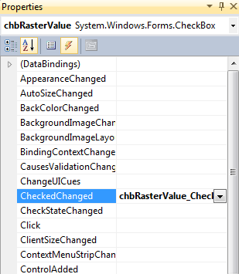
fig.5 ChbRasterValue checkbox's checked changed event.

chbRasterValue_CheckedChanged event should has the following events.

private void chbRasterValue_CheckedChanged(object sender, EventArgs e)
{
if (chbRasterValue.Checked)
{
IMapRasterLayer rasterLayer = map1.Layers.SelectedLayer as IMapRasterLayer ;

if ((rasterLayer != null))
{
//set the map cursor to cross
map1.Cursor = Cursors.Cross;
}
else
{
//if no raster layer is selected, uncheck the checkbox
MessageBox.Show("Please select a raster layer.");
chbRasterValue.Checked = false;
}
}
else
{
//change map cursor back to arrow
map1.Cursor = Cursors.Arrow;
}

}

Select the Map1's mouse up event.
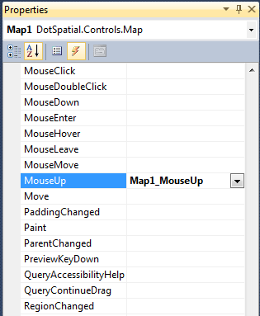
fig.6 Map1_MouseUp event
map1_MouseUp event should have the following code.
private void map1_MouseUp(object sender, MouseEventArgs e)
{
if (chbRasterValue.Checked)
{
//get the layer selected in the legend
IMapRasterLayer rasterLayer = map1.Layers.SelectedLayer as IMapRasterLayer;

if ((rasterLayer != null))
{

//get the raster data object
IRaster raster = rasterLayer.DataSet;

//convert mouse position to map coordinate
Coordinate coord = map1.PixelToProj(e.Location);

//convert map coordinate to raster row and column
RcIndex rc = raster.Bounds.ProjToCell(coord);

int row = rc.Row;

int column = rc.Column;

//check if clicked point is inside of raster
if ((column > 0 & column < raster.NumColumns & row > 0 & row < raster.NumRows))
{
//get the raster value at row and column
double value = raster.Value[row, column];

//show the row, column and value in the label
lblRasterValue.Text = string.Format("row: {0} column: {1} value: {2}", row, column, value);
}
else
{
lblRasterValue.Text = "outside of raster";
}

}

}

}

Output screen shot for different operations.
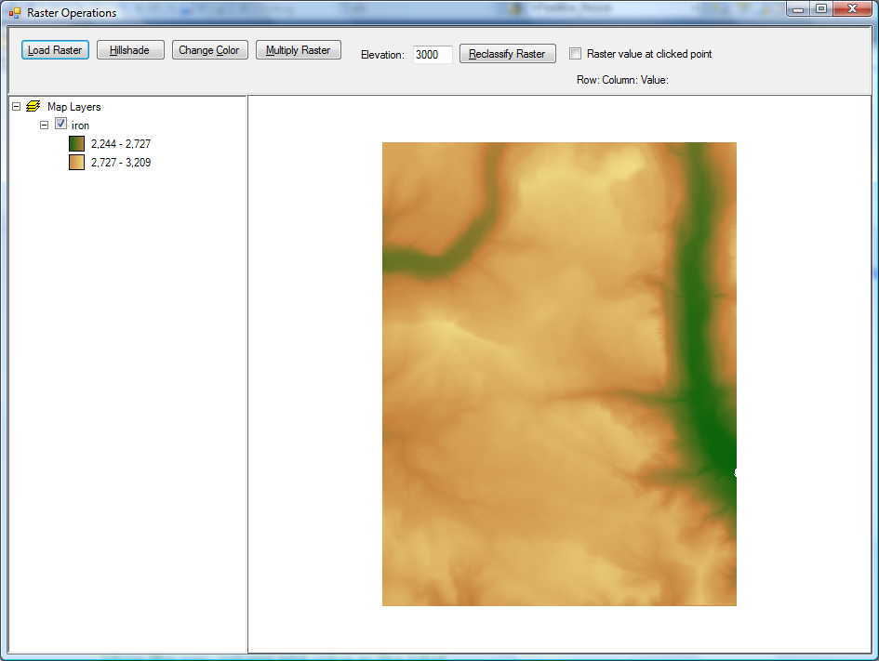
Fig.7 Load a raster data
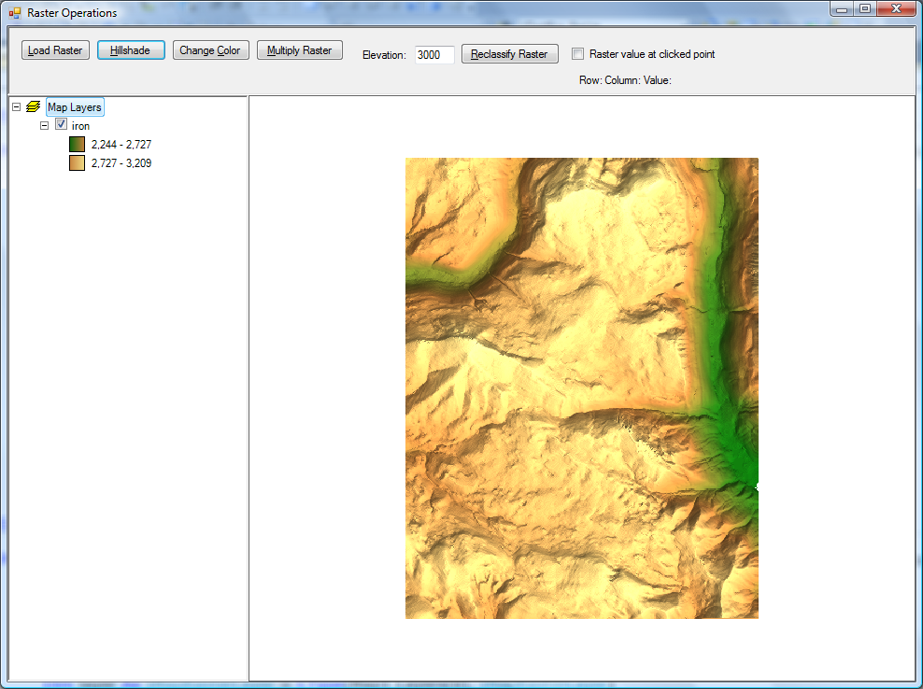
Fig.8 After the hill shade operation

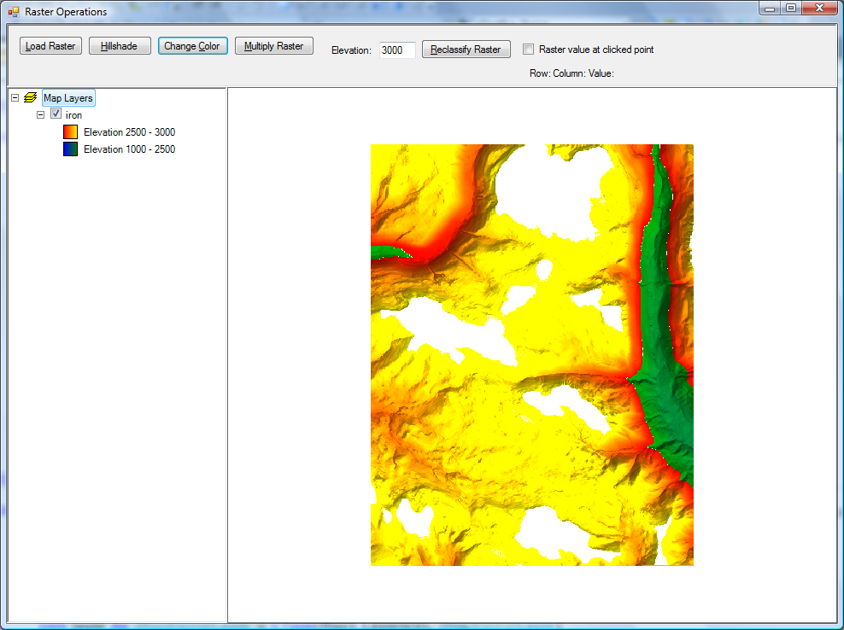
Fig.9 After the color change operation

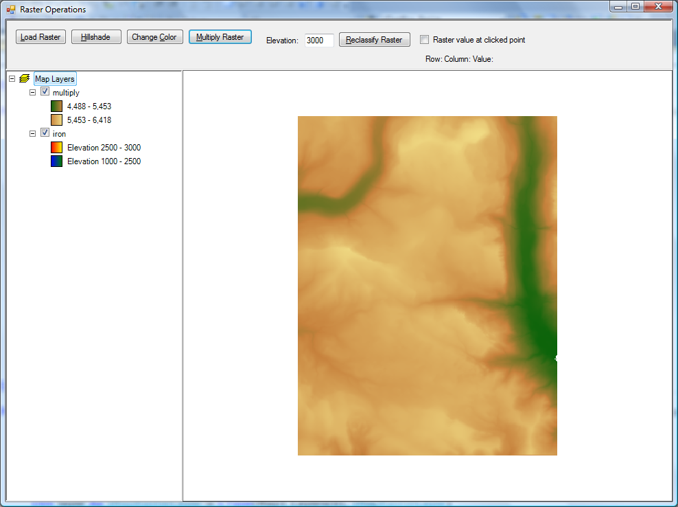
Fig.10 After the raster multiplication
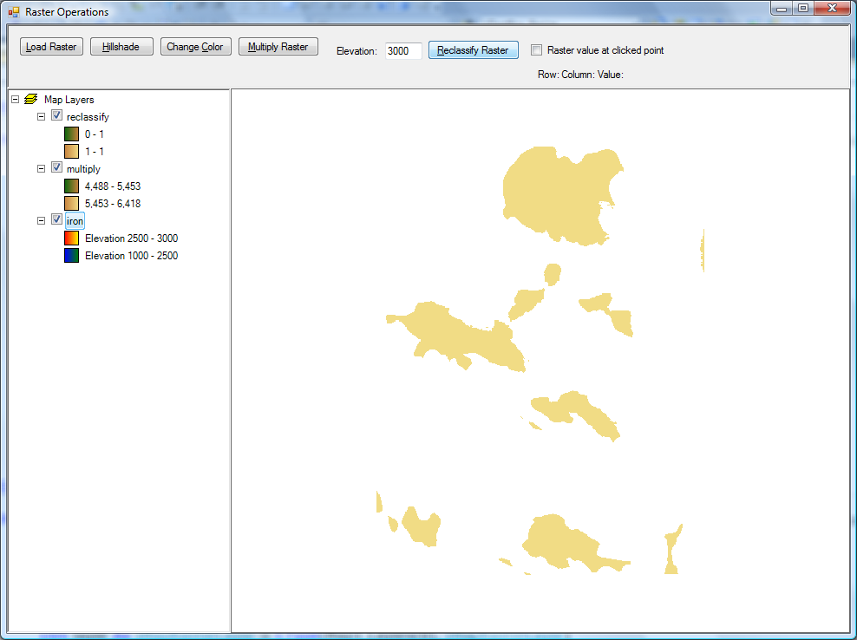
Fig.11 After the reclassify operation
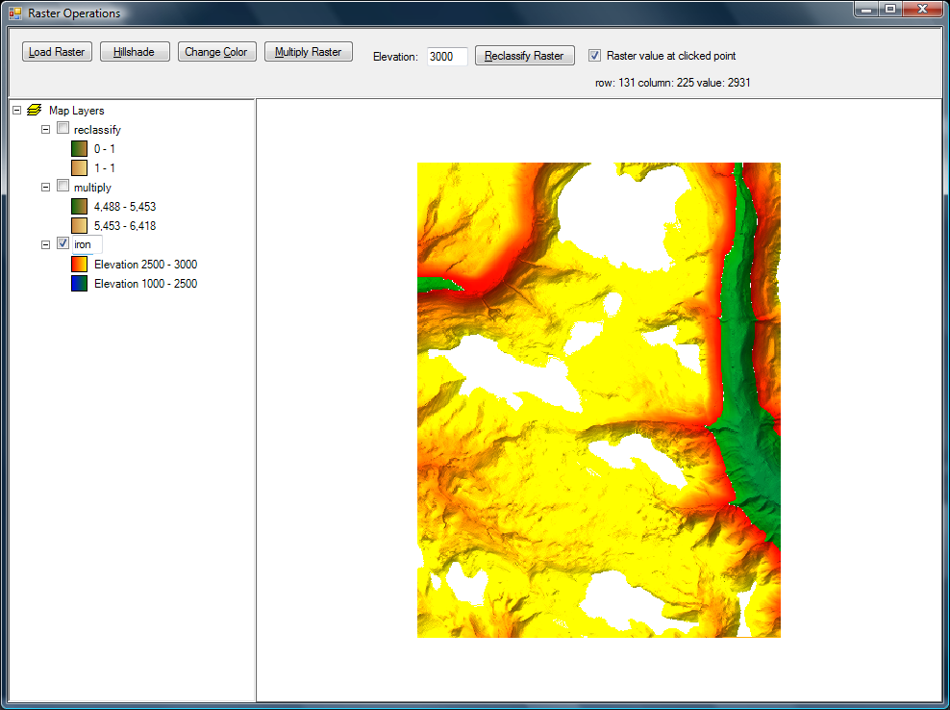
Fig.12 Getting the mouse click point value on the raster data file.

