Projection Explorer in DotSpatial
  - Tutorial (5)
Purpose of this tutorial: Become familiar with working with projections in DotSpatial:
Specifically, we will build an application that allows the user to view a polygon shapefile in multiple projections simultaneously and to explore the effect of different projections on area calculations.
This tutorial has 5 important steps.
Step 1: Download the DotSpatial class library
Step 2: Add the DotSpatial reference and change the compile option.
Step 3: Add the DotSpatial Controls into the Visual Studio Toolbox.
Step 4: Design the GUI. (GUI - Graphical User Interface)
Step 5: Write the code for implementing the map operations.
Step 1: Download the DotSpatial class library
This step is similar to the Tutorial #1 step 1.
Step 2: Add the DotSpatial reference and change the compile option.
2.1) Add the required DotSpatial reference in the visual studio development environment.
Create a new VB or C# application and right click over the project on the solution explorer. On the context menu select the add reference and add the following reference from the DotSpatial folder.
DotSpatial.Controls, DotSpatial.Data, DotSpatial.Data.Forms, DotSpatial.Serialization, DotSpatial.Symbology, DotSpatial.Topology.
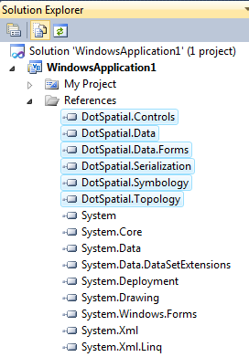
fig.1. (Required DotSpatial.dlls)

2.2) Change the compile option from .Net FrameWork 4 Client Profile to .Net FrameWork 4
This step is as same as the Tutorial # 1 step 2.2.
Step 3: Add the DotSpatial Controls into the Visual Studio Toolbox.
This step is as same as the Tutorial # 1 step 3.
Step 4: Design the GUI. (Graphical User Interface)
Design the GUI as follows:
4.1) Add a panel control and set its properties as follows:
Name : pnlMain
Autoscroll : True
Dock : Fill
BorderStyle : Fixed Single

4.2) Add 6 more panels on the pnlMain as follows:
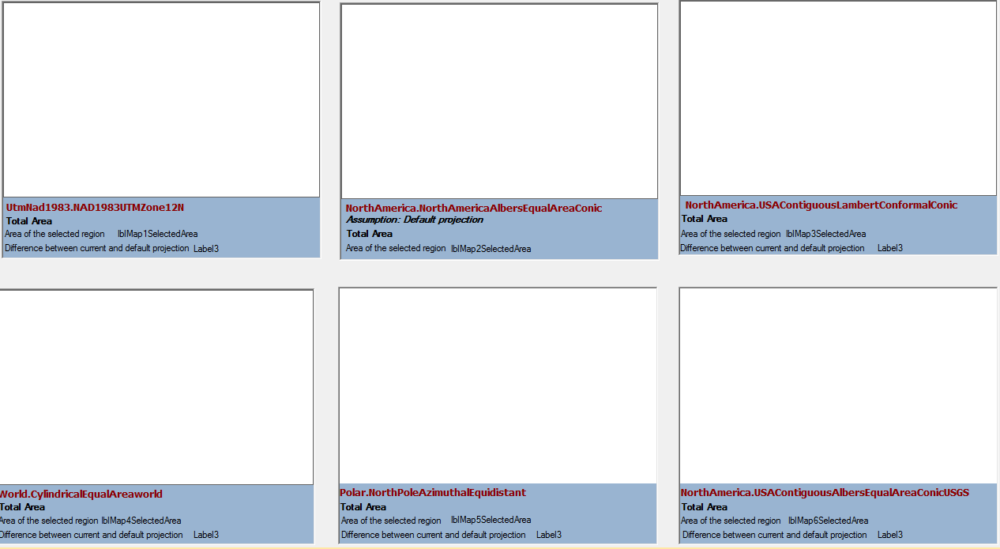
Fig. 3 Six different panels on the main panel control.
Set the above six panels' properties as follows:
Controls | Name | BackColor | BorderStyle
Panel1 | pnlMap1 | ActiveCaption | Fixed3D
Panel2 | pnlMap2 | ActiveCaption | Fixed3D
Panel3 | pnlMap3 | ActiveCaption | Fixed3D
Panel4 | pnlMap4 | ActiveCaption | Fixed3D
Panel5 | pnlMap5 | ActiveCaption | Fixed3D
Panel6 | pnlMap6 | ActiveCaption | Fixed3D

4.3) Add 6 map controls into the above panel controls.
Set the map properties as follows:
Dock : top
The following figure shows indicates the order in which the map controls should be placed on their associated panel controls.
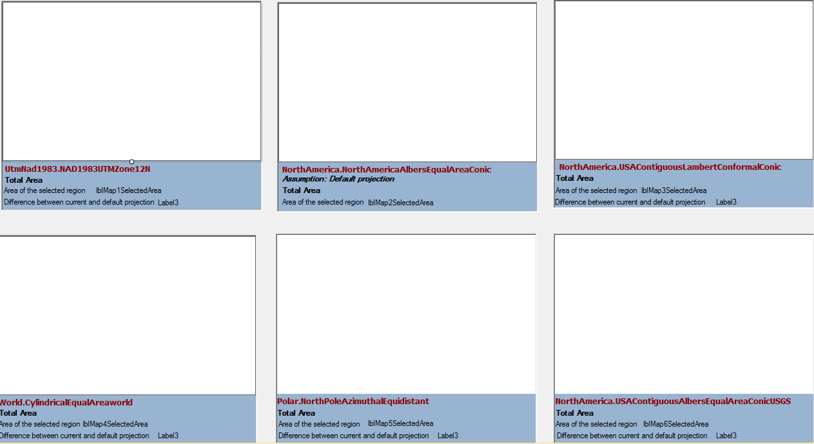
Map6
Map4
Map5
Map2
Map3
Map1
fig. 4 . Map Controls
4.4) Add the 37 labels described below.
4.4.1) Place the first label at the top of your form to serve as a title for the page. Set its label properties as follows:
Name : lbltitle
ForeColor : Blue ( Optional)
Text : Projection Explorer!!! (or use a title of your choosing).
4.4.2) Set the other 36 labels’ properties as follows:
Controls | Name | ForeColor | Text | Visible
label1 | lblmap1Projection | DarkRed | UtmNad1983.NAD1983UTMZone12N | True
label2 | lblmap2Projection | DarkRed | NorthAmerica.NorthAmericaAlbersEqualAreaConic | True
label3 | lblmap3Projection | DarkRed | NorthAmerica.USAContiguousLambertConformalConic | True
label4 | lblmap4Projection | DarkRed | World.CylindricalEqualAreaworld | True
label5 | lblmap5Projection | DarkRed | Polar.NorthPoleAzimuthalEquidistant | True
label6 | lblmap6Projection | DarkRed | NorthAmerica.USAContiguousAlbersEqualAreaConicUSGS | True
label7 | lbltotalAreaMap1 | ControlText | Total Area | True
label8 | lbltotalAreaMap2 | ControlText | Total Area | True
label9 | lbltotalAreaMap3 | ControlText | Total Area | True
label10 | lbltotalAreaMap4 | ControlText | Total Area | True
label11 | lbltotalAreaMap5 | ControlText | Total Area | True
label12 | lbltotalAreaMap6 | ControlText | Total Area | True
label13 | lblmap1selectedinfo | ControlText | Area of the selected region | False
label14 | lblmap2selectedinfo | ControlText | Area of the selected region | False
label15 | lblmap3selectedinfo | ControlText | Area of the selected region | False
label16 | lblmap4selectedinfo | ControlText | Area of the selected region | False
label17 | lblmap5selectedinfo | ControlText | Area of the selected region | False
label18 | lblmap6selectedinfo | ControlText | Area of the selected region | False
label19 | lblMap1SelectedArea | ControlText |  | True
label20 | lblMap1SelectedArea | ControlText |  | True
label21 | lblMap2SelectedArea | ControlText |  | True
label22 | lblMap3SelectedArea | ControlText |  | True
label23 | lblMap4SelectedArea | ControlText |  | True
label24 | lblMap5SelectedArea | ControlText |  | True
label25 | lblMap6SelectedArea | ControlText |  | True
label26 | lblmap1info | ControlText | Difference between current and default projection | False
label27 | lblmap2info | ControlText | Difference between current and default projection | False
label28 | lblmap3info | ControlText | Difference between current and default projection | False
label29 | lblmap4info | ControlText | Difference between current and default projection | False
label30 | lblmap5info | ControlText | Difference between current and default projection | False
label31 | lblmap6info | ControlText | Difference between current and default projection | False
label32 | lblmap1difference | ControlText |  | False
label33 | lblmap2assumption | ControlText | Assumption: Default projection | True
label34 | lblmap2difference | ControlText |  | False
label35 | lblmap2difference | ControlText |  | False
label36 | lblmap2difference | ControlText |  | False
Following figure shows the label controls configuration.
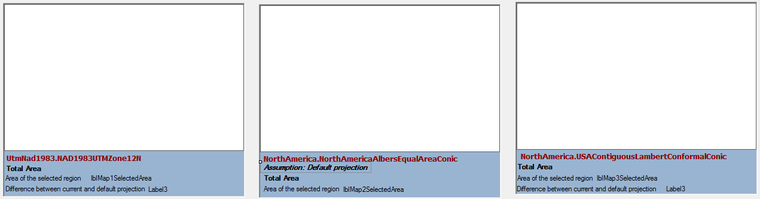
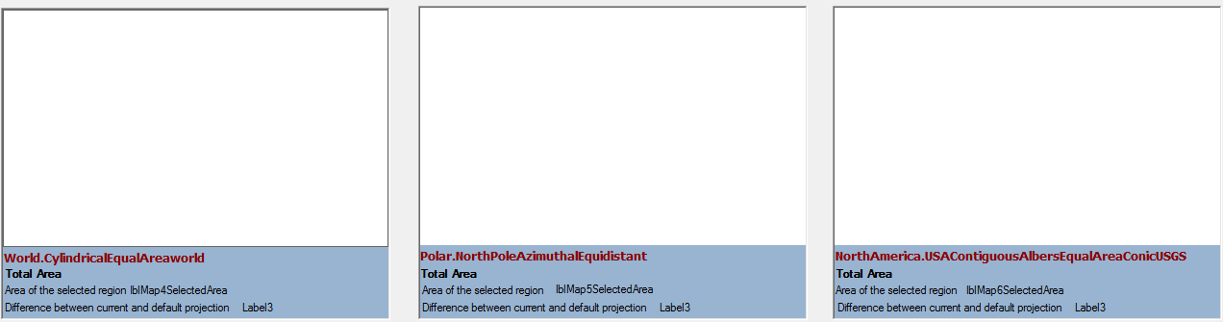
fig.5 label control in the panel

4.5) Add 2 group boxes and set its properties as follows:
First Groupbox's name : gbBasciOperations , Text : Basci Operations
Second Groupbox's name : gbAdvancedOperations , Text = Advanced Operations
4.6 ) Add 2 buttons on the gbBasciOperations.
Set buttons' properties as follows:
Button 1 : Name : btnLoadShapeFile
Font : Tahoma, 8.25pt, style=Bold
Button 2 : Name : btnGetTotalArea
Font : Tahoma, 8.25pt, style=Bold
4.7) Add 2 buttons, 2 labels, and 2 combo box on the gbAdvancedOperations as the following figure:
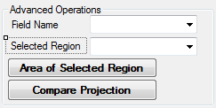
Set the controls properties as follows:
Control | Name | Text
Label1 | lblFieldName | Field Name
Label2 | lblSelectedRegion | Selected Region
Combobox | cmbFiledName
Combobox | cmbSelectedRegion
Button1 | btnRegionArea
Button2 | btnCompareProjections

Final Graphical User Interface should look like as follows:
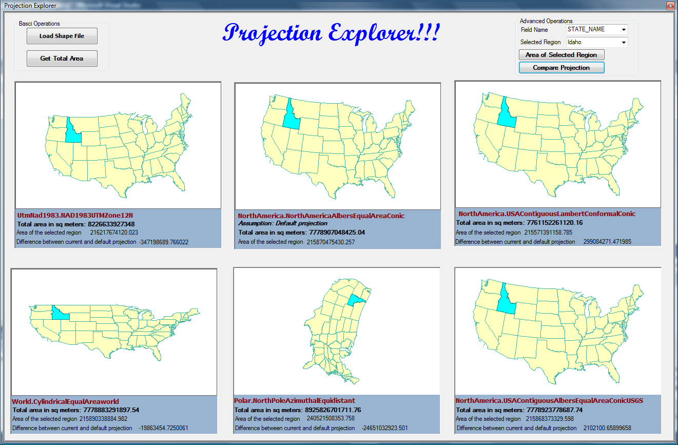
Fig. 6 Final Graphical User Interface.
Step 5: Code implementation
Add the following namespaces
VB
'Required namespces
Imports DotSpatial.Projections
Imports DotSpatial.Data
Imports DotSpatial.Controls

C#
//Required namespaces
using DotSpatial.Controls;
using DotSpatial.Projections;
using DotSpatial.Data;

Write the following code under btnLoadShapeFile_click event.

VB

Private Sub btnLoadShapeFile_Click(ByVal sender As System.Object, ByVal e As System.EventArgs) Handles btnLoadShapeFile.Click
'define the projections
Map1.Projection = KnownCoordinateSystems.Projected.UtmNad1983.NAD1983UTMZone12N
Map2.Projection = KnownCoordinateSystems.Projected.NorthAmerica.NorthAmericaAlbersEqualAreaConic
Map3.Projection = KnownCoordinateSybn stems.Projected.NorthAmerica.USAContiguousLambertConformalConic
Map4.Projection = KnownCoordinateSystems.Projected.World.CylindricalEqualAreaworld
Map5.Projection = KnownCoordinateSystems.Projected.Polar.NorthPoleAzimuthalEquidistant
Map6.Projection = KnownCoordinateSystems.Projected.NorthAmerica.USAContiguousAlbersEqualAreaConicUSGS

'add the layers
Dim fileDialog As New OpenFileDialog()
fileDialog.Filter = "Shapefiles|*.shp"
If fileDialog.ShowDialog = DialogResult.OK Then

'add layer to first map
Dim featureSet1 As New FeatureSet
featureSet1.Open(fileDialog.FileName)

'Populate the FiledName dropdownlist with the help of featureset1.
'We need to pass featureset as an input paramter to FillColumnNames method.
FillColumnNames(featureSet1)

'set the projection
featureSet1.Reproject(Map1.Projection)
Map1.Layers.Add(featureSet1)

'add layer to second map
Dim featureSet2 As New FeatureSet
featureSet2.Open(fileDialog.FileName)
featureSet2.Reproject(Map2.Projection)
Map2.Layers.Add(featureSet2)

'add layer to map3
Dim featureSet3 As New FeatureSet
featureSet3.Open(fileDialog.FileName)
featureSet3.Reproject(Map3.Projection)
Map3.Layers.Add(featureSet3)

'add layer to map4
Dim featureSet4 As New FeatureSet
featureSet4.Open(fileDialog.FileName)
featureSet4.Reproject(Map4.Projection)
Map4.Layers.Add(featureSet4)

'add layer to map5
Dim featureSet5 As New FeatureSet
featureSet5.Open(fileDialog.FileName)
featureSet5.Reproject(Map5.Projection)
Map5.Layers.Add(featureSet5)

'add layer to map6
Dim featureSet6 As New FeatureSet
featureSet6.Open(fileDialog.FileName)
featureSet6.Reproject(Map6.Projection)
Map6.Layers.Add(featureSet6)
End If
End Sub

C#

private void btnLoadShapeFile_Click(object sender, EventArgs e)
{
//define the projections
map1.Projection = KnownCoordinateSystems.Projected.UtmNad1983.NAD1983UTMZone12N;
map2.Projection = KnownCoordinateSystems.Projected.NorthAmerica.NorthAmericaAlbersEqualAreaConic;
map3.Projection = KnownCoordinateSystems.Projected.NorthAmerica.USAContiguousLambertConformalConic;
map4.Projection = KnownCoordinateSystems.Projected.World.CylindricalEqualAreaworld;
map5.Projection = KnownCoordinateSystems.Projected.Polar.NorthPoleAzimuthalEquidistant;
map6.Projection = KnownCoordinateSystems.Projected.NorthAmerica.USAContiguousAlbersEqualAreaConicUSGS;

//add the layers
OpenFileDialog fileDialog = new OpenFileDialog();
fileDialog.Filter = "Shapefiles|*.shp";

if (fileDialog.ShowDialog() == DialogResult.OK)
{

//add layer to first map
FeatureSet featureSet1 = new FeatureSet();
featureSet1.Open(fileDialog.FileName);

//Populate the FiledName dropdownlist with the help of featureset1.
//We need to pass featureset as an input paramter to FillColumnNames method.
FillColumnNames(featureSet1);

//set the projection
featureSet1.Reproject(map1.Projection);
map1.Layers.Add(featureSet1);

//add layer to second map
FeatureSet featureSet2 = new FeatureSet();
featureSet2.Open(fileDialog.FileName);
featureSet2.Reproject(map2.Projection);
map2.Layers.Add(featureSet2);

//add layer to map3
FeatureSet featureSet3 = new FeatureSet();
featureSet3.Open(fileDialog.FileName);
featureSet3.Reproject(map3.Projection);
map3.Layers.Add(featureSet3);

//add layer to map4
FeatureSet featureSet4 = new FeatureSet();
featureSet4.Open(fileDialog.FileName);
featureSet4.Reproject(map4.Projection);
map4.Layers.Add(featureSet4);

//add layer to map5
FeatureSet featureSet5 = new FeatureSet();
featureSet5.Open(fileDialog.FileName);
featureSet5.Reproject(map5.Projection);
map5.Layers.Add(featureSet5);

//add layer to map6
FeatureSet featureSet6 = new FeatureSet();
featureSet6.Open(fileDialog.FileName);
featureSet6.Reproject(map6.Projection);
map6.Layers.Add(featureSet6);
}

}

Write the following code under btnGetTotalArea_Click event.

VB

Private Sub btnGetTotalArea_Click(ByVal sender As System.Object, ByVal e As System.EventArgs) Handles btnGetTotalArea.Click
lbltotalAreaMap1.Text = "Total area in sq meters: " + _getTotalArea(Map1).ToString()
lblAreaMap2.Text = "Total area in sq meters: " + _getTotalArea(Map2).ToString()
lblAreaMap3.Text = "Total area in sq meters: " + _getTotalArea(Map3).ToString()
lblAreaMap4.Text = "Total area in sq meters: " + _getTotalArea(Map4).ToString()
lblAreaMap5.Text = "Total area in sq meters: " + _getTotalArea(Map5).ToString()
lblAreaMap6.Text = "Total area in sq meters: " + _getTotalArea(Map6).ToString()
End Sub

C#

private void btnGetTotalArea_Click(object sender, EventArgs e)
{
lbltotalAreaMap1.Text = "Total area in sq meters: " + _getTotalArea(map1).ToString();
lbltotalAreaMap2.Text = "Total area in sq meters: " + _getTotalArea(map2).ToString();
lbltotalAreaMap3.Text = "Total area in sq meters: " + _getTotalArea(map3).ToString();
lbltotalAreaMap4.Text = "Total area in sq meters: " + _getTotalArea(map4).ToString();
lbltotalAreaMap5.Text = "Total area in sq meters: " + _getTotalArea(map5).ToString();
lbltotalAreaMap6.Text = "Total area in sq meters: " + _getTotalArea(map6).ToString();
}

Write a private function as follows: This is used to get the total are of the shape file.

VB

''' <summary>
''' This method is used to claculate total area of a feature
''' </summary>
''' <param name="mapInput">map control</param>
''' <returns>total are of the feature from the mapcontrol</returns>
''' <remarks></remarks>
Private Function _getTotalArea(ByVal mapInput As DotSpatial.Controls.Map) As Double
Dim stateArea As Double
If (mapInput.Layers.Count > 0) Then
Dim stateLayer As MapPolygonLayer
stateLayer = CType(mapInput.Layers(0), MapPolygonLayer)
If (stateLayer Is Nothing) Then
MessageBox.Show("The layer is not a polygon layer.")
Else
For Each stateFeature As IFeature In stateLayer.DataSet.Features
stateArea += stateFeature.Area
Next
End If
End If
Return stateArea
End Function

C#

/// <summary>
/// This method is used to claculate total area of a feature
/// </summary>
/// <param name="mapInput">map control</param>
/// <returns>total are of the feature from the mapcontrol</returns>
/// <remarks></remarks>
private double _getTotalArea(DotSpatial.Controls.Map mapInput)
{
double stateArea = 0;
if ((mapInput.Layers.Count > 0))
{
MapPolygonLayer stateLayer = default(MapPolygonLayer);
stateLayer = (MapPolygonLayer)mapInput.Layers[0];
if ((stateLayer == null))
{
MessageBox.Show("The layer is not a polygon layer.");
}
else
{
foreach (IFeature stateFeature in stateLayer.DataSet.Features)
{
stateArea += stateFeature.Area();
}
}
}
return stateArea;
}

Write the following sub method to populate the fieldnames on the fieldname combo box.

VB

''' <summary>
''' This method is used to populate the FieldName combobox
''' </summary>
''' <param name="featureSet"></param>
''' <remarks></remarks>
Private Sub FillColumnNames(ByVal featureSet As IFeatureSet)
For Each column As DataColumn In featureSet.DataTable.Columns
cmbFiledName.Items.Add(column.ColumnName)
Next
End Sub

C#

/// <summary>
/// This method is used to populate the FieldName combobox
/// </summary>
/// <param name="featureSet"></param>
/// <remarks></remarks>
private void FillColumnNames(IFeatureSet featureSet)
{
foreach (DataColumn column in featureSet.DataTable.Columns)
{
cmbFiledName.Items.Add(column.ColumnName);
}
}

Write the following sub method for populating the cmbSelectedRegion combo box.

VB

''' <summary>
''' This method is used to fill the unique values on the cmbSelectedRegion combobox
''' </summary>
''' <param name="uniqueField">Fieldname combobox's selected value</param>
''' <param name="mapInput">Map layer</param>
''' <remarks></remarks>
Private Sub FillUniqueValues(ByVal uniqueField As String, ByVal mapInput As DotSpatial.Controls.Map)
Dim fieldList As New List(Of String)
If (mapInput.Layers.Count > 0) Then
Dim currentLayer As MapPolygonLayer
currentLayer = CType(mapInput.Layers(0), MapPolygonLayer)
If (currentLayer Is Nothing) Then
MessageBox.Show("The layer is not a polygon layer.")
Else
Dim dt As DataTable = currentLayer.DataSet.DataTable
cmbSelectedRegion.Items.Clear()
For Each rows As DataRow In dt.Rows
cmbSelectedRegion.Items.Add(rows(uniqueField))
Next
End If
End If
End Sub

C#

/// <summary>
/// This method is used to fill the unique values on the cmbSelectedRegion combobox
/// </summary>
/// <param name="uniqueField">Fieldname combobox's selected value</param>
/// <param name="mapInput">Map layer</param>
/// <remarks></remarks>
private void FillUniqueValues(string uniqueField, DotSpatial.Controls.Map mapInput)
{
List<string> fieldList = new List<string>();
if ((mapInput.Layers.Count > 0))
{
MapPolygonLayer currentLayer = default(MapPolygonLayer);
currentLayer = (MapPolygonLayer)mapInput.Layers[0];
if ((currentLayer == null))
{
MessageBox.Show("The layer is not a polygon layer.");
}
else
{
DataTable dt = currentLayer.DataSet.DataTable;
cmbSelectedRegion.Items.Clear();
foreach (DataRow rows in dt.Rows)
{
cmbSelectedRegion.Items.Add(rows[uniqueField]);
}
}
}
}

Write the following code in the cmbFiledName_SelectedIndexChanged event.

VB

Private Sub cmbFiledName_SelectedIndexChanged(ByVal sender As System.Object, ByVal e As System.EventArgs) Handles cmbFiledName.SelectedIndexChanged
FillUniqueValues(cmbFiledName.Text, Map1)
End Sub

C#

private void cmbFiledName_SelectedIndexChanged(object sender, EventArgs e)
{
FillUniqueValues(cmbFiledName.Text, map1);

}

Write the following sub method.

VB

''' <summary>
''' This sub method is used to control the visibility of any label control
''' </summary>
''' <param name="lbl">label name</param>
''' <param name="vis">Either True / False</param>
''' <remarks></remarks>
Private Sub setVisible(ByVal lbl As Label, ByVal vis As Boolean)
lbl.Visible = vis
End Sub

C#

/// <summary>
/// This sub method is used to control the visibility of any label control
/// </summary>
/// <param name="lbl">label name</param>
/// <param name="vis">Either True / False</param>
/// <remarks></remarks>
private void setVisible(Label lbl, bool vis)
{
lbl.Visible = vis;
}

Write the following function for getting the selected region's area.

VB

''' <summary>
''' This method is used to get the area of the selected region on the combobox
''' </summary>
''' <param name="uniqueColumnName">Field name</param>
''' <param name="uniqueValue">Unique value from the selected region combobox</param>
''' <param name="mapInput">map layer</param>
''' <returns>area of the selected field</returns>
''' <remarks></remarks>
Private Function _getArea(ByVal uniqueColumnName As String, ByVal uniqueValue As String, ByVal mapInput As DotSpatial.Controls.Map) As Double
Dim stateArea As Double
If (mapInput.Layers.Count > 0) Then
Dim stateLayer As MapPolygonLayer
stateLayer = CType(mapInput.Layers(0), MapPolygonLayer)
If (stateLayer Is Nothing) Then
MessageBox.Show("The layer is not a polygon layer.")
Else
stateLayer.SelectByAttribute("[" + uniqueColumnName + "] =" + "'" + uniqueValue + "'")
For Each stateFeature As IFeature In stateLayer.DataSet.Features
If uniqueValue = stateFeature.DataRow(uniqueColumnName) Then
stateArea = stateFeature.Area
Exit For
End If
Next
End If
End If
Return stateArea
End Function

C#

/// <summary>
/// This method is used to get the area of the selected region on the combobox
/// </summary>
/// <param name="uniqueColumnName">Field name</param>
/// <param name="uniqueValue">Unique value from the selected region combobox</param>
/// <param name="mapInput">map layer</param>
/// <returns>area of the selected field</returns>
/// <remarks></remarks>
private double _getArea(string uniqueColumnName, string uniqueValue, DotSpatial.Controls.Map mapInput)
{
double stateArea = 0;
if ((mapInput.Layers.Count > 0))
{
MapPolygonLayer stateLayer = default(MapPolygonLayer);
stateLayer = (MapPolygonLayer)mapInput.Layers[0];
if ((stateLayer == null))
{
MessageBox.Show("The layer is not a polygon layer.");
}
else
{
stateLayer.SelectByAttribute("[" + uniqueColumnName + "] =" + "'" + uniqueValue + "'");
foreach (IFeature stateFeature in stateLayer.DataSet.Features)
{
if (uniqueValue.CompareTo(stateFeature.DataRow[uniqueColumnName]) == 0)
{
stateArea = stateFeature.Area();
break; // TODO: might not be correct. Was : Exit For
}
}
}
}
return stateArea;
}

Write the following code in the btnRegionArea_click event.

VB

Private Sub btnRegionArea_Click(ByVal sender As System.Object, ByVal e As System.EventArgs) Handles btnRegionArea.Click
setVisible(lblmap1selectedinfo, True)
setVisible(lblmap2selectedinfo, True)
setVisible(lblmap3selectedinfo, True)
setVisible(lblmap4selectedinfo, True)
setVisible(lblmap5selectedinfo, True)
setVisible(lblmap6selectedinfo, True)
lblMap1SelectedArea.Text = _getArea(cmbFiledName.Text, cmbSelectedRegion.Text, Map1)
lblMap2SelectedArea.Text = _getArea(cmbFiledName.Text, cmbSelectedRegion.Text, Map2)
lblMap3SelectedArea.Text = _getArea(cmbFiledName.Text, cmbSelectedRegion.Text, Map3)
lblMap4SelectedArea.Text = _getArea(cmbFiledName.Text, cmbSelectedRegion.Text, Map4)
lblMap5SelectedArea.Text = _getArea(cmbFiledName.Text, cmbSelectedRegion.Text, Map5)
lblMap6SelectedArea.Text = _getArea(cmbFiledName.Text, cmbSelectedRegion.Text, Map6)
End Sub

C#

private void btnRegionArea_Click(object sender, EventArgs e)
{
setVisible(lblmap1selectedinfo, true);
setVisible(lblmap2selectedinfo, true);
setVisible(lblmap3selectedinfo, true);
setVisible(lblmap4selectedinfo, true);
setVisible(lblmap5selectedinfo, true);
setVisible(lblmap6selectedinfo, true);
lblMap1SelectedArea.Text = _getArea(cmbFiledName.Text, cmbSelectedRegion.Text, map1).ToString();
lblMap2SelectedArea.Text = _getArea(cmbFiledName.Text, cmbSelectedRegion.Text, map2).ToString();
lblMap3SelectedArea.Text = _getArea(cmbFiledName.Text, cmbSelectedRegion.Text, map3).ToString();
lblMap4SelectedArea.Text = _getArea(cmbFiledName.Text, cmbSelectedRegion.Text, map4).ToString();
lblMap5SelectedArea.Text = _getArea(cmbFiledName.Text, cmbSelectedRegion.Text, map5).ToString();
lblMap6SelectedArea.Text = _getArea(cmbFiledName.Text, cmbSelectedRegion.Text, map6).ToString();
}

Write the following function to calculate the difference between projections.

VB

''' <summary>
''' This function is used to claculate the difference between 2 ares
''' </summary>
''' <param name="area1"></param>
''' <param name="area2"></param>
''' <returns></returns>
''' <remarks></remarks>
Private Function _calculateDifference(ByVal area1 As Double, ByVal area2 As Double) As Double
Dim areadiff As Double
areadiff = area1 - area2
Return areadiff
End Function

C#

/// <summary>
/// This function is used to claculate the difference between 2 ares
/// </summary>
/// <param name="area1"></param>
/// <param name="area2"></param>
/// <returns></returns>
/// <remarks></remarks>
private double _calculateDifference(double area1, double area2)
{
double areadiff = 0;
areadiff = area1 - area2;
return areadiff;
}

Write the following code under the compare projection button click event.

VB

Private Sub btnCompareProjections_Click(ByVal sender As System.Object, ByVal e As System.EventArgs) Handles btnCompareProjections.Click
lblmap1difference.Text = _calculateDifference(CDbl(lblMap2SelectedArea.Text), CDbl(lblMap1SelectedArea.Text)).ToString()
lblmap3difference.Text = _calculateDifference(CDbl(lblMap2SelectedArea.Text), CDbl(lblMap3SelectedArea.Text)).ToString()
lblmap4difference.Text = _calculateDifference(CDbl(lblMap2SelectedArea.Text), CDbl(lblMap4SelectedArea.Text)).ToString()
lblmap5difference.Text = _calculateDifference(CDbl(lblMap2SelectedArea.Text), CDbl(lblMap5SelectedArea.Text)).ToString()
lblmap6difference.Text = _calculateDifference(CDbl(lblMap2SelectedArea.Text), CDbl(lblMap6SelectedArea.Text)).ToString()

setVisible(lblmap1difference, True)
setVisible(lblmap1info, True)
setVisible(lblmap3difference, True)
setVisible(lblmap3info, True)
setVisible(lblmap4difference, True)
setVisible(lblmap4info, True)
setVisible(lblmap5difference, True)
setVisible(lblmap5info, True)
setVisible(lblmap6difference, True)
setVisible(lblmap6info, True)
End Sub

C#

private void btnCompareProjections_Click(object sender, EventArgs e)
{
lblmap1difference.Text = _calculateDifference(Convert.ToDouble(lblMap2SelectedArea.Text), Convert.ToDouble(lblMap1SelectedArea.Text)).ToString();
lblmap3difference.Text = _calculateDifference(Convert.ToDouble(lblMap2SelectedArea.Text), Convert.ToDouble(lblMap3SelectedArea.Text)).ToString();
lblmap4difference.Text = _calculateDifference(Convert.ToDouble(lblMap2SelectedArea.Text), Convert.ToDouble(lblMap4SelectedArea.Text)).ToString();
lblmap5difference.Text = _calculateDifference(Convert.ToDouble(lblMap2SelectedArea.Text), Convert.ToDouble(lblMap5SelectedArea.Text)).ToString();
lblmap6difference.Text = _calculateDifference(Convert.ToDouble(lblMap2SelectedArea.Text), Convert.ToDouble(lblMap6SelectedArea.Text)).ToString();

setVisible(lblmap1difference, true);
setVisible(lblmap1info, true);
setVisible(lblmap3difference, true);
setVisible(lblmap3info, true);
setVisible(lblmap4difference, true);
setVisible(lblmap4info, true);
setVisible(lblmap5difference, true);
setVisible(lblmap5info, true);
setVisible(lblmap6difference, true);
setVisible(lblmap6info, true);
}

Output of the project for different shape files

1. US states shape file :

fig.6 US states.shp shape file output

2: US Lakes :

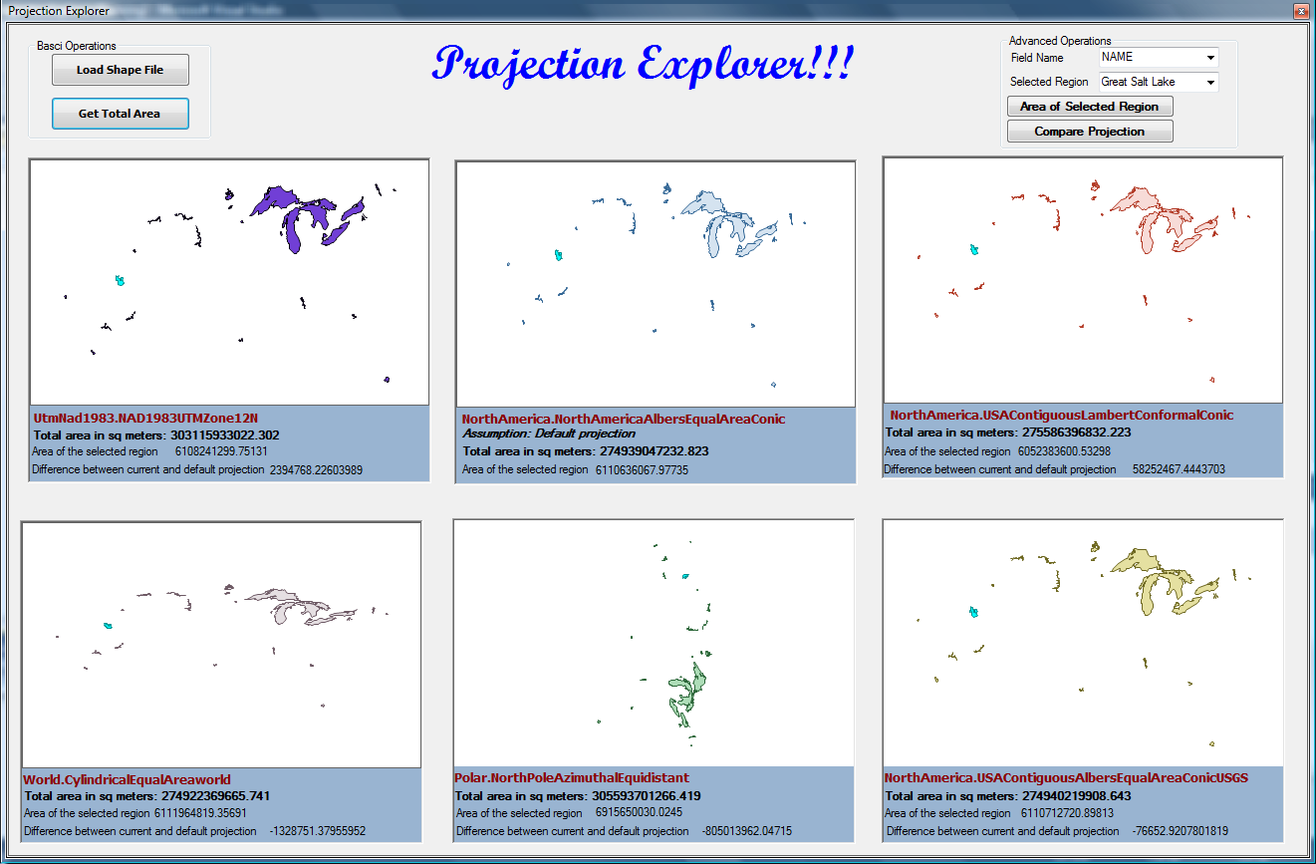
fig.7. US lakes output

