Create a custom plug-in DotSpatial.

Tutorial (8)
Purpose of this tutorial: Designing a custom plug-in in DotSpatial.
For example the following plug-in is used to get points form an Excel worksheet and plot them on the map.
Step 1: Create a new project in Visual Studio Environment. Choose the New Project under the File menu. In the New Project window select the Online Templates and type the DotSpatial in the search dialog box.
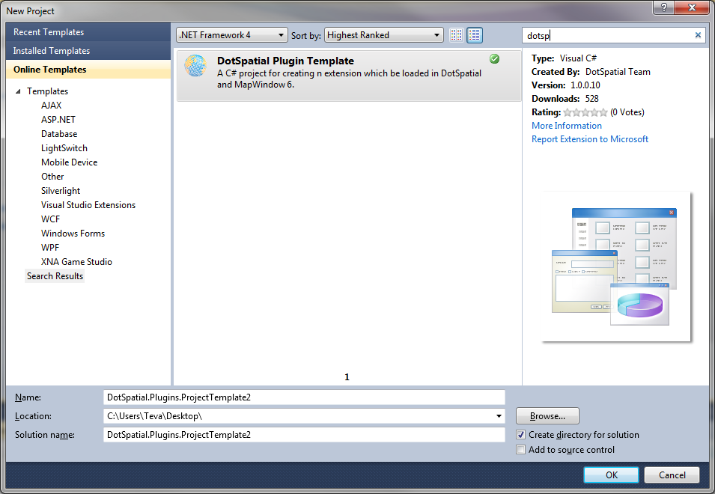
Fig.1
Step 2: Double click on the DotSpatial Plugin Template to create the plug-in project.
Step 3: Get the DotSpatial dlls from http://dotspatial.codeplex.com

Step 4: Unblock the downloaded folder before unzip it. Go to the properties of the downloaded folder. On the properties window click the unblock button.

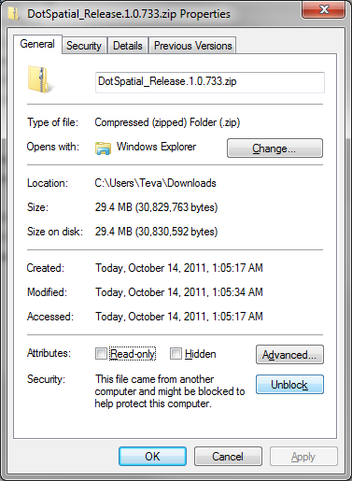
Fig.2 Unblocking the folder

Step 6: Set the reference path to those dlls.
a) Select the project in Solution Explorer and choose Properties
b) Go to the Reference Paths tab
c) Browse to the location of the DotSpatial dlls
d) Click Add Folder

Step 6: Change the compile option from .Net Framework 4 to .Net Framework4. Set the Build output path to the plug-in folder under the DotSptial downloaded folder. Fig. 3

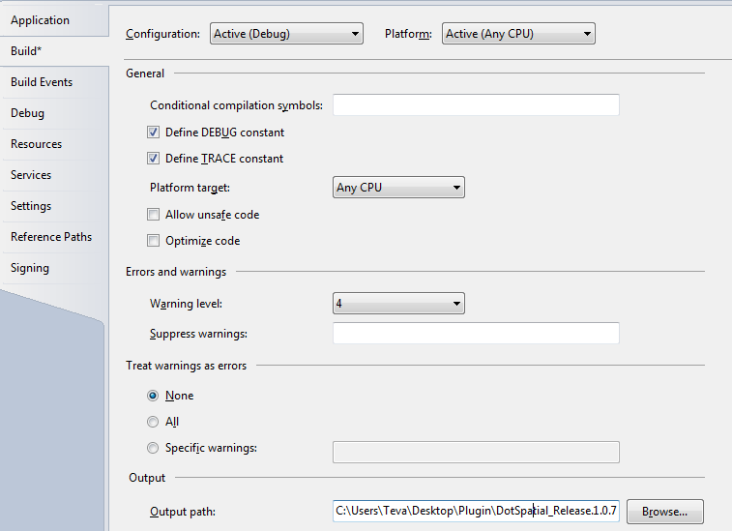
Fig.3 set the output path
On the Debug tab select the start external program tab and redirect/give your Demomap.exe file path. It should be under the DotSpatial download folder.
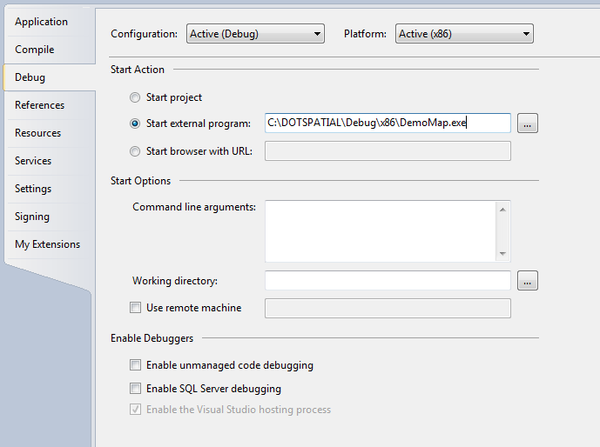
Fig.4 (Run the DemoMap.exe)
Step 7: Code implementation.
Add a new form in the existing project and set its properties as follows:
Text: Demo Plug-in
Add a button on the form and set its properties as follows:
Name: btnImportExcel
Text: Import Excel Points
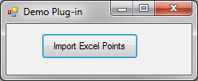
Fig.5 Form GUI
Write the following code in the MyPlugin1.cs class.
public override void Activate()
{
App.HeaderControl.Add(new SimpleActionItem("Teva_Plugin", ButtonClick));
base.Activate();
}

public override void Deactivate()
{
App.HeaderControl.RemoveAll();
base.Deactivate();
}

public void ButtonClick(object sender, EventArgs e)
{
Form1 frm = new Form1(App);
frm.Show();
}

Write the following code in the form:
- Imports the following name spaces.
using System.Data.OleDb;
using DotSpatial.Data;
using DotSpatial.Topology;
using DotSpatial.Projections;
using DotSpatial.Controls;

- Declare the following class level variable.
AppManager appManager;

- Create the following constructor code.
public Form1(AppManager app)
{
InitializeComponent();
appManager = app;
}

- Add the following code in the btnImportExcel_Click event.

private void btnExcelExport_Click(object sender, EventArgs e)
{
OpenFileDialog openDialog = new OpenFileDialog();
openDialog.Filter = "Excel Files|*.xlsx";
if (openDialog.ShowDialog() == DialogResult.OK)
{
dynamic excelFileName = openDialog.FileName;

dynamic connectionString = "Provider=Microsoft.ACE.OLEDB.12.0;Data Source=" + excelFileName + ";Extended Properties=\"Excel 12.0 Xml;HDR=YES;IMEX=1\"";

OleDbConnection connection = new OleDbConnection(connectionString);

string query = "SELECT * FROM [Sheet1$]";

connection.Open();

OleDbCommand command = new OleDbCommand(query, connection);
OleDbDataAdapter adapter = new OleDbDataAdapter(command);
DataTable excelTable = new DataTable();
adapter.Fill(excelTable);

connection.Close();

//check if table has the lat, long columns

if (excelTable.Columns.Contains("lat") & excelTable.Columns.Contains("long"))
{
//create a feature set and show it on the map
FeatureSet fs = new FeatureSet(FeatureType.Point);
fs.Projection = KnownCoordinateSystems.Geographic.World.WGS1984;

//set columns of attribute table
fs.DataTable = excelTable.Clone();

foreach (DataRow excelRow in excelTable.Rows)
{
double lat = Double.Parse(excelRow["lat"].ToString());
double lon = Double.Parse(excelRow["long"].ToString());

Coordinate coord = new Coordinate(lon, lat);
DotSpatial.Topology.Point p = new DotSpatial.Topology.Point(coord);
dynamic feature = fs.AddFeature(p);

for (int i = 0; i <= excelTable.Columns.Count - 1; i++)
{
feature.DataRow[i] = excelRow[i];
}
}

//add feature set to map
dynamic layer = appManager.Map.Layers.Add(fs);
layer.LegendText = "My Points";

}
else
{
MessageBox.Show("The excel table doesn't have columns lat and long.");
}
}
this.Close();
}

Step 8: Create an Excel Work sheep as follows:

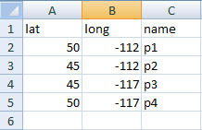 Fig.6 Excel worksheet data
Step 9: Output screen shot.

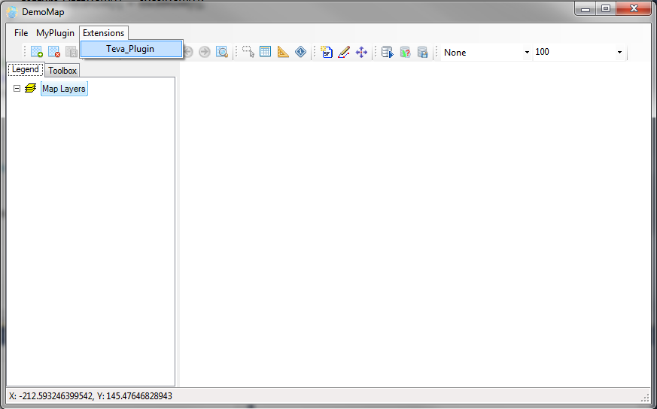
Fig.7 Run the Teva Plug-in

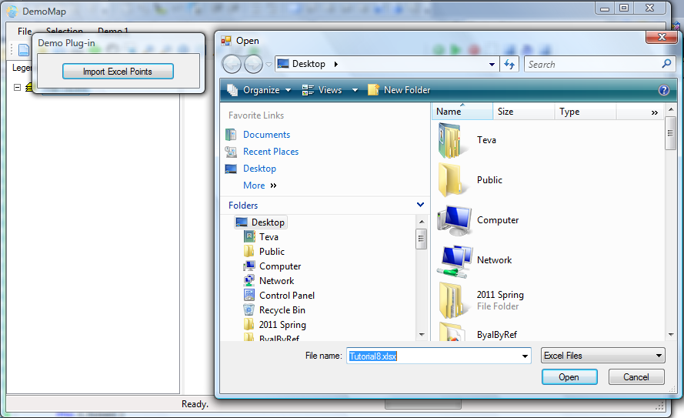
Fig.8. After clicks the Import Excel Points button.

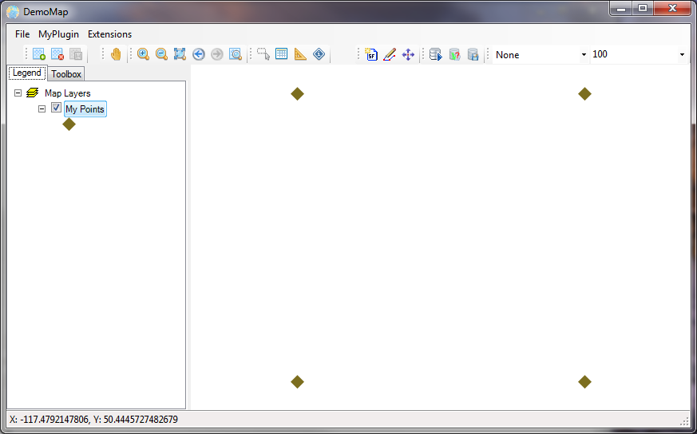
Fig.9 Final output

Create a menu item for your plugin

Write the following code in the MyPlugin1.cs class

public override void Activate()
{
App.HeaderControl.Add(new RootItem("test_root_key", "Test Menu Item"));
App.HeaderControl.Add(new SimpleActionItem("test_root_key","Teva_Plugin", ButtonClick));
base.Activate();
}

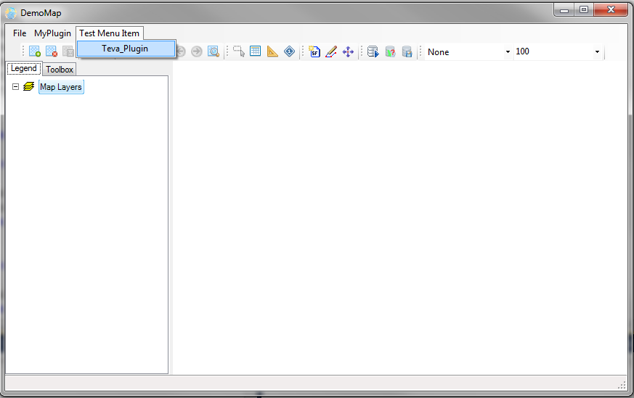
Fig.10 Create a menu item for the plugin

